# Screen shots of the online database portal phpMyAdmin

Import function of website database

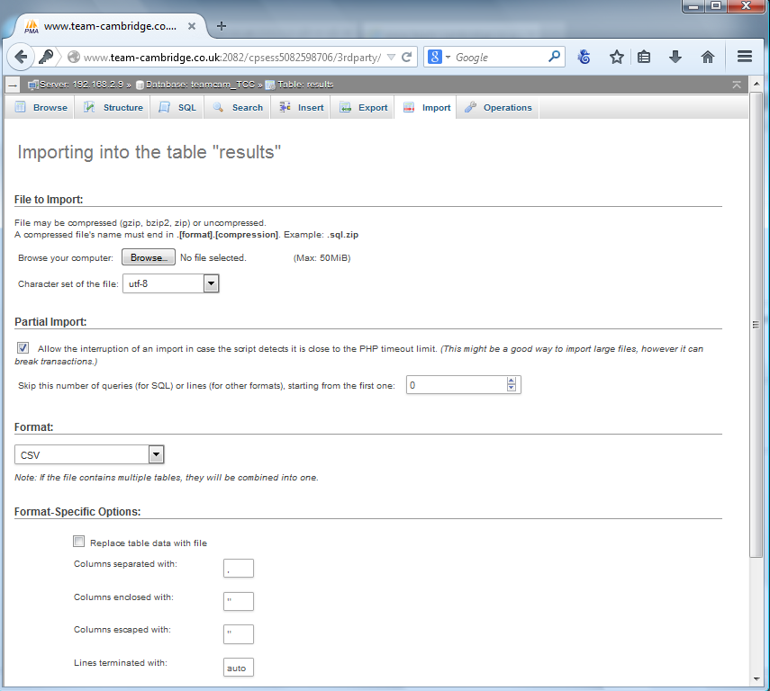

Database structure

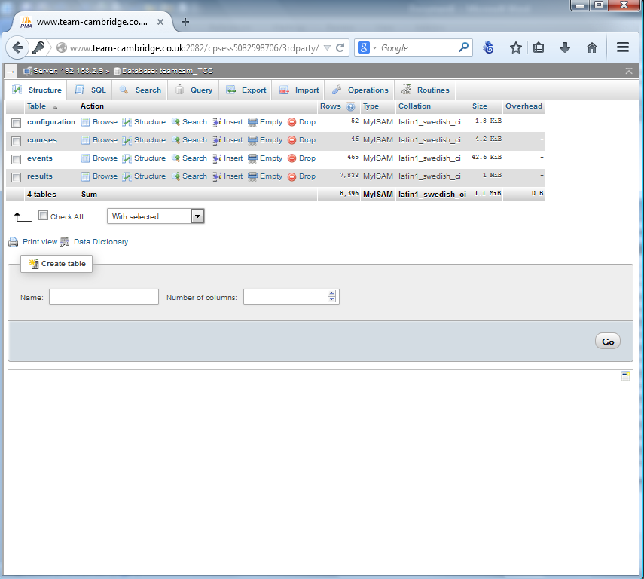

Structure of the ‘Results’ database

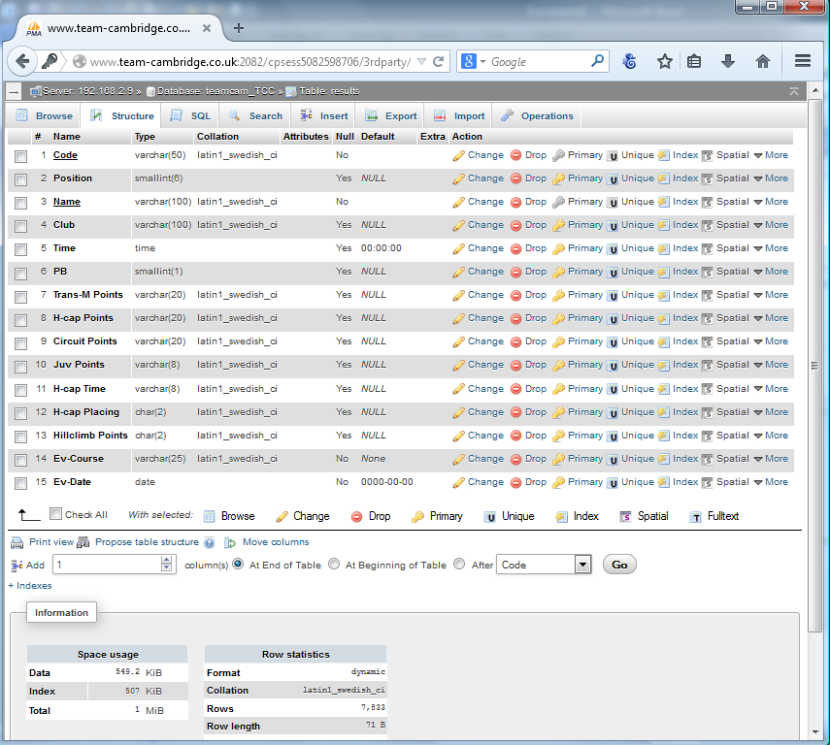

# Screen shots of the MS Excel ‘Results’ calculation spreadsheet

Event calculation page - this shows highlighted cells alerting to joint equal times and the need to apply equal points. Also of the insertion of a blank time slot, where a rider missed their start position.

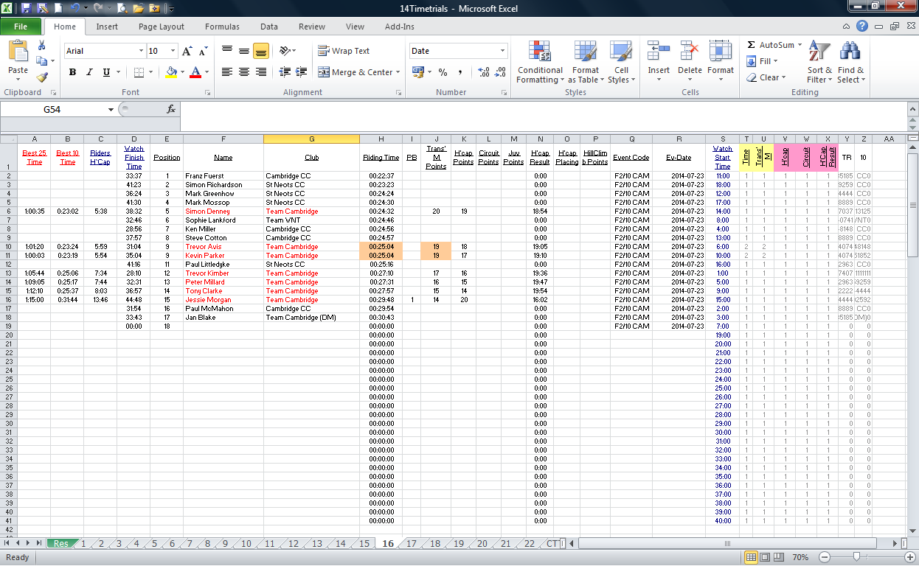

Handicap lookup page (3900 lines)

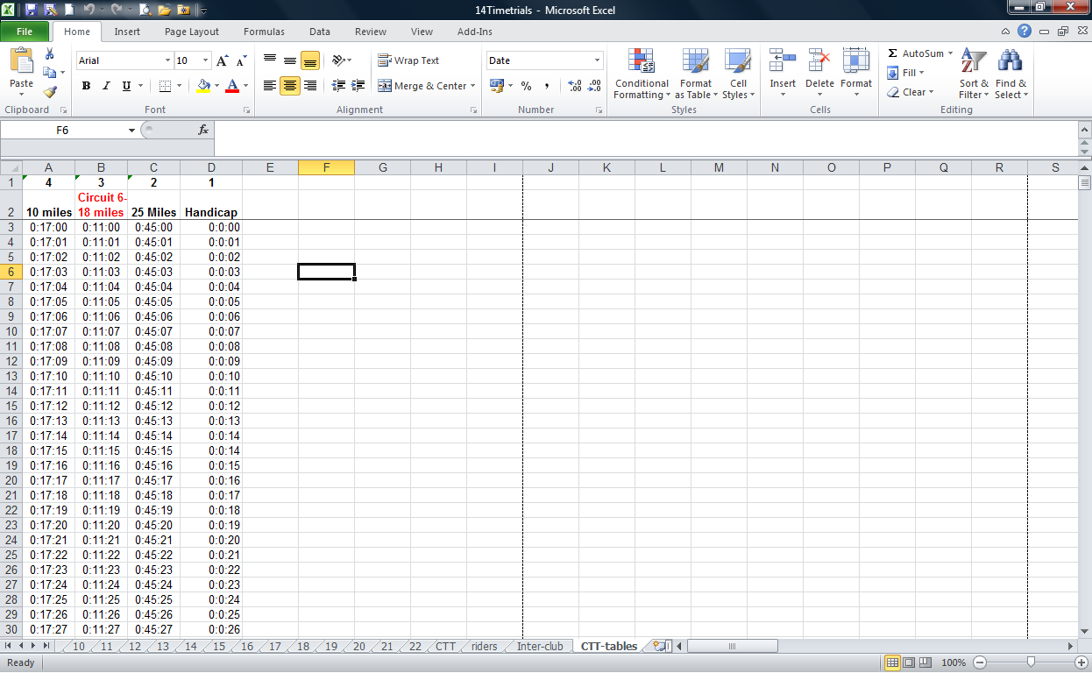

Blank results page with a list of 180 riders to select from, which speeds up data entry.

